**AI Chatbot For HealthCare**

**Project Report**

Project Work Phase-2 (ECS-899)

Degree

**BACHELOR OF TECHNOLOGY (CSE)**

PROJECT GUIDE: SUBMITTED BY:

**Mr. Aaditya Jain** **Arjun Sharma (TCA1809067)**

**Assistant Professor** **Nameera Meraj (TCA1911003)**

**Raushan Raaz(TCA1809060)**

SESSION 2021-2022



**FACULTY OF ENGINEERING & COMPUTING SCIENCES**

**TEERTHANKER MAHAVEER UNIVERSITY, MORADABAD**

**DECLARATION**

We hereby declare that this Project Report titled **Artificial Chatbot for Health Care** submitted by us and approved by our project guide, Faculty of Engineering & Computing Sciences. Teerthanker Mahaveer University, Moradabad, is a bonafide work undertaken by us and it is not submitted to any other University or Institution for the award of any degree diploma / certificate or published any time before.

|  |  |  |
| --- | --- | --- |
|  |  |  |
| **Project ID :** | 15 |  |
| **Student Name:** | Raushan Raj  (TCA1809060) | Signature |
| **Student Name:** | Nameera Miraj  (TCA1911003) | Signature |
| **Student Name:** | Arjun Sharma  (TCA1809067) | Signature |
|  |  |  |
| **Project Guide :**  **(Internal)**  **Project Guide:**  **(External)** | Mr. Aaditya Jain    Name | Signature  Signature |
|  |  |  |
|  |  |  |

**Table of Contents**

**1 PROJECT TITLE ................................................................................................................. 01**

**2 PROBLEM STATEMENT ...................................................................................................03**

**3 PROJECT DESCRIPTION .....................................................................................................05**

### 3.1 SCOPE OF THE WORK .................................................................................................06 3.2 PROJECT MODULES ................................................................................................. ..07

**3.3 CONTEXT DIAGRAM (HIGH LEVEL) ......................................................................... ……..09**

**4 IMPLEMENTATION METHODOLOGY ..................................................................................11**

**5 TECHNOLOGIES TO BE USED ............................................................................................ .13**

### 5.1 SOFTWARE PLATFORM ............................................................................................... 14 5.2 HARDWARE PLATFORM................................................................................................15

**5.3 TOOLS, IF ANY ......................................................................................................………16**

1. **ADVANTAGES OF THIS PROJECT ..................................................................................... 17**
2. **ASSUMPTIONS, IF ANY ................................................................................................... 20**
3. **FUTURE SCOPE AND FURTHER ENHANCEMENT OF THE PROJECT ....................................26**
4. **PROJECT REPOSITORY LOCATION .................................................................................. 28**
5. **DEFINITIONS, ACRONYMS, AND ABBREVIATIONS ...........................................................30**
6. **CONCLUSION .................................................................................................................35**
7. **REFERENCES ...................................................................................................................37**

**Appendix**

**A: Data Flow Diagram (DFD)**

**B: Entity Relationship Diagram (ERD)**

**C: Data Dictionary (DD)**

**D: Screen Shots**

# Project Title

**Ai Chatbot For HealthCare** Explore how health care organizations can scale up their CX journey with Conversational AI Categorize calls based on customer requirements with Conversational AI. Predictive Analytics.

# Problem Statement

In Today’s World Scenarios traditional method to getting appointment for doctor, standing in long queues for number of hours also doctors didn’t talk as if patient want more consult regarding their health. Also, Patient health record history, their previous prescribed medicine and what’s their suitable medicine all need an IT solution in terms of Artificial Intelligence. Artificial intelligence chatbot is a technology that makes interactions between man and machines using natural language possible

# Project Description

The purpose of this project is to provide the admin has to collect the patient’s medical history of records and filter it appropriately by applying data pre-processing techniques. Admin’s functionalities are to collecting the appropriate medical records of the patients, handle missing values, handling categorical values, creating sparse matrix representation, feeding data to the autonomous pipeline for predictions, selecting and training an appropriate machine learning algorithm.

The visitor can perform the basic task of the visitor is to access the Chatbot from the front end and reply to its queries with a binary response (Yes/No). The visitor will be shown a confidence interval related to a certain prognosis which needs to further investigated and experimented with for better results. The first step is to start their procedure, then one by one all the symptoms come in client’s screens. They will have to reply with yes or no answer.

Once a problem is found then they will have to click yes, then the patient can see their problem on screen. The best part is that it will provide the doctor’s information like the Doctor’s name and his/her website link. So thar can easily find their doctor with don’t face with any type of problem, and start their treatment. This will prepare with the help of Chatbot so that one can even check their problem at any time. You have to just reply with the clicking of button Yes or No. Artificial intelligence is now at its peak and chatbot is just one example of its use to contribute to progress. It should also be made clear that chatbots are not designed to diagnose patients. The idea presented was to use artificial intelligence to create a medical chatbot that could provide some basic details about the disease before consulting a doctor.

Text-to-text medical chatbots enable patients to talk about their medical problems and provide personalized diagnosis based on symptoms. The patient can then be transferred to a specialist. This sequence of things fundamentally saves the doctor's time. In turn, chatbots are always available to help people in need of medical assistance.

In addition, the virtual assistant may be responsible for reminding users to take medication and monitoring the patient's health status. Generally, chatbots communicate with real people. Chatbots are used in applications such as e-commerce customer service, call centres and internet games. However, with a chatbot, one can communicate with a text or voice interface and get responses through artificial intelligence Chatbots are programs designed to automatically involve with received messages.

The chatbot can be programmed to respond same way to respond differently to messages containing certain keywords every time and even use machine learning to adapt its response to suit the situation. Moreover, numerous hospitals, nursing homes, and even private centres are currently using online chatbots to provide human services on their sites. These chatbots connect with potential patients who visit the site, help them find experts, schedule appointments, and get them the right treatment. Regardless, in industries where people's lives may be questioned, the use of artificial intelligence is still beginning to raise doubts. It raised questions as to whether the above tasks should be assigned to personnel.

This medical Chatbot system will help hospitals provide 24 x 7 online healthcare support online, and it can answer deep as well as general questions.

It also helps generate leads and automatically pass information about leads to sales by asking questions continuously, and also can guide the patient's exact needs and help the patient to look for what she/he wants. Chatbot usage is user friendly and can be used by anyone. However, medical chatbots can provide personalized diagnosis based on symptoms. In the future, by adding support for more medical functions such as location, duration, intensity of symptoms, and more detailed description of symptoms, the chatbot's symptom recognition and diagnostic performance can be greatly improved.

The future is the era of messaging applications, because people will spend more time on messaging app than any other apps. Therefore, medical chatbots have a broad and broad future and no matter how far people are, they can have this medical conversation. By adding more word combinations and increasing the use of databases, the efficiency of chatbots can be improved, so that medical chatbots can handle all types of diseases.

The proposed system will engage patients into a conversational text agent that helps the patients with their health issues. and patients can chat as if they are chatting with a human. The patients then issue the chatbot their manifestation to diagnose the disease. It gives different recommendations about the different manifestations to clarify the disease. When the right disease is found, it recommends the patients the cure and the doctor who needs to be consulted in case of major disease. From the review of different journals, it is concluded that, the usage of Chatbot is user friendly and can be used by anyone who knows how to type in their own language in mobile app or desktop version. A medical chatbot provides personalized diagnoses based on symptoms. In the future, the bot’s symptom recognition and diagnosis performance could be much improved by adding support for more medical features, for instance location, duration, and intensity of symptoms, and more detailed symptom description. The implementation of customized Medical assistant heavily relies on AI algorithms as well as the training data. At the end, the implementation of customized medicine would successfully save many lives and create a medical awareness among people. As mentioned before, the future era is the era of messaging app because people going to spend more time in messaging app than any other apps. Therefore, medical chatbot has huge and large future scope. No matter how far they are, people can have this medical conversation. The only requirement they would need is a simple desktop or smartphone with internet connection. The efficient of the chatbot can be improved by adding more combination of words and increasing the use of database so that of the medical chatbot could handle all type of diseases. Even voice conversation can be added in the system to make it easier to use.

It is developed using the python Language. Based on the survey given it is found that the number of correct answer given by the chatbot is 80% and incorrect/ambiguous answer given is 20%. From this survey of chatbot and examination of result proposed that this software can be used for teaching and as a virtual doctor for recognition and main healthcare.

Chatbots are usually used to engage conversation between both human and machine. The user feeds some knowledge to the machine so that machine can identify the sentences and taking a decision itself as a response to answer a question. It can neglect in describing a sentence and how to the response it whereas linking chat request to the database. So, knowledge demonstration and function of SQL in the pattern-matching operation are needed. The deliberation by the chat-bots would be verified back to the fundamental model. It is done so that it can add some knowledge to the database as it has not been formed before. If in case the input sentences in the database did not match then it will be reformed.

So far, chat-bots are been applied in health education, diagnostics and mental health. A survey of conversational agents from 40 articles outlines chat-bot taxonomy, specifies the main challenges and defines the types and contexts related to chat-bots in health.

For instance, chat-bots can provide instant responses to health-related enquiries from patients while looking for specific patterns of symptoms in predicting disease, as presented by the internet-based Doc-Bot delivered via mobile phone or a Messenger-based chat-bot for outpatient and translational medicine.

Chat-bots, as part of Artificial Intelligence devices, are natural language processing systems acting as a virtual conversational agent impersonate human interactions.

While this technology is still in its developmental stage, health chat-bots could potentially increase access to healthcare, improve doctor–patient and clinic–patient communication, or help to manage the increasing demand for health services such as via remote testing, medication adherence observing or teleconsultations.

The chat-bot technology enables for such activities as specific health surveys, setting up personal health-related reminders, communication with clinical teams, booking appointments, retrieving and examine health data or the translation of diagnostic patterns taking into account performance indicators such as physical activity, sleep or nutrition.

A Chatbot needs to be natural at responding to the user messages and therefore it needs

to have a sustainable back-end logic to process user inputs and parameters to generate

results.

## Scope of the Work

1. This project consists number of patients history, their health records and previous prescriptions.
2. This work help visitor to get health related advice and suggests experts of their fields.
3. Provide maximum accuracy in result of health issues based on Symptom’s Based Query.
4. Chatbots have an ability to engage customers. They can also foster a relationship between customer and brands, and deliver a more personalized experience. Bots impart information about new product launches and timely updates to the customers.
5. The Chatbots are the computer Programs that interact with the users using natural language.
6. The Chatbots stores the information in the database to identify the keywords from the sentences and make a decision for the query and answer the questions.

## Project Modules

**Problem Recognition**: The Problem Recognition Module is responsible for understanding the visitor’s problem through basic Yes/No queries.

**Evaluation and synthesis**: This module evaluate the problem into different segments and synthesis the collect data and feed into the module*.*

**Modelling**: This module is responsible for processing evaluated data and determine the issue occur in the data entry.

**Result:** After the model process the problem, this led to the result of the problem recognized by the HealthCare Chatbot.

* **Features :**- Register Screen.
* Sign-in Screen.
* Generates database for user login system.
* Offers you a GUI Based Chatbot for patients for diagnosing. [A pragmatic Approach for Diagnosis]
* Recommends an appropriate doctor to you for the following symptom.

## Modules Used

Our program uses a number of python modules to work properly:

1. tkinter
2. os
3. web browser
4. NumPy
5. pandas
6. matplotlib

## Installation

Install the following package by typing the following in CMD

* pip install numpy
* pip install pandas
* pip install matplotlib

To make sure it is installed correctly, open IDLE and execute:

* import numpy
* import pandas
* import matplotlib

If no errors appeared then the installation is done correctly. Then, go to your directory and run the file QuestionDiagonosisTkinter.py

**Category:** Machine Learning, AI: **-** Artificial intelligence (AI) and machine learning are often used interchangeably, but machine learning is a subset of the broader category of AI.

**Programming Language:** Python**:-** Python is a popular programming language. It was created by Guido van Rossum, and released in 1991.

It is used for:

* web development (server-side),
* software development,
* mathematics,
* system scripting.

**IDE:** Jupyter notebookProject Jupyter builds tools, standards, and services for many different use cases. This page has links to interactive demos that allow you to try some our tools for free online, thanks to [mybinder.org](https://mybinder.org/), a free public service provided by the Jupyter community.

**Front End:** Tkinter **:-** The [tkinter](https://docs.python.org/3/library/tkinter.html" \l "module-tkinter) package (“Tk interface”) is the standard Python interface to the Tcl/Tk GUI toolkit. Both Tk and [tkinter](https://docs.python.org/3/library/tkinter.html" \l "module-tkinter) are available on most Unix platforms, including macOS, as well as on Windows systems.

Running Python from the command line should open a window demonstrating a simple Tk interface, letting you know that [tkinter](https://docs.python.org/3/library/tkinter.html" \l "module-tkinter) is properly installed on your system, and also showing what version of Tcl/Tk is installed, so you can read the Tcl/Tk documentation specific to that version.

Tkinter supports a range of Tcl/Tk versions, built either with or without thread support. The official Python binary release bundles Tcl/Tk 8.6 threaded. See the source code for the _tkinter module for more information about supported versions.

Tkinter is not a thin wrapper, but adds a fair amount of its own logic to make the experience more pythonic. This documentation will concentrate on these additions and changes, and refer to the official Tcl/Tk documentation for details that are unchanged.

**Back End:** Python: NumPy, Pandas, MessaseBox, Web Browser

**Prerequisities:** Python, Machine Learning

1. **Intended Audience:** Education, Developers, Data Scientists, AI professionals

* **Skills Prerequisites for Machine Learning :**
* [Probability](https://www.naukri.com/learning/articles/prerequisites-for-machine-learning/" \l "prob)
* [Linear Algebra](https://www.naukri.com/learning/articles/prerequisites-for-machine-learning/" \l "linear)
* [Calculus](https://www.naukri.com/learning/articles/prerequisites-for-machine-learning/" \l "cal)
* [Statistics](https://www.naukri.com/learning/articles/prerequisites-for-machine-learning/" \l "stat)

### ****Probability****

### In [probability, we talk about the probability of an uncertain event](https://www.naukri.com/learning/articles/introduction-to-probability/). Probability plays an important role in tasks associated with large-scale data collection and interpretation, making it an essential tool for machine learning.

**Topics to Learn** –

* Random Variables
* Random Experiment
* Conditional Probability
  + [Bayes’ Theorem](https://www.naukri.com/learning/articles/introduction-to-bayes-theorem/)
* Probability Distributions –
  + Uniform
  + Bernoulli
  + Binomial
  + Poisson
  + Normal

### ****Linear Algebra****

Linear Algebra appears practically everywhere. It will be necessary to understand the basic properties of vectors and matrices, matrix multiplication, special matrices, Gauss-Jordan elimination, etc.

Linear Algebra is important to learn the fundamentals of working with data in vector and matrix form. You would need to solve systems of linear algebraic equations and find the basic matrix decompositions and their applications

**Topics to Learn :–**

* Matrix
* Vector Spaces
* Eigenvalues & Eigenvectors
* Singular Value Decomposition (SVD)
* Lower–Upper (LU) Decomposition
* Orthogonalization & Orthonormalization
* QR Decomposition/Factorization
* Symmetric Matrices
* Matrix Operations
* Projections

### ****Calculus:-****

Calculus plays an important role in building machine learning models. It can be considered as a set of tools to analyze relationships between functions and their inputs. As a machine learning aspirant, you should be familiar with –

* Iintegration
* Differentiation
* Partial Derivatives
* Vector-Values Functions
* Directional Derivative
* Gradient, Hessian, Jacobian, Laplacian and Lagragian Distribution

### ****Statistics :-****

You would need to have the [knowledge of statistical concepts](https://www.naukri.com/learning/articles/basic-of-statistics-for-data-science/) when dealing with data and drawing conclusions from it.

**Topics to Learn :–**

[**Measures of Central Tendency**](https://www.naukri.com/learning/articles/introduction-to-inferential-statistics/)

* Mean
* Median
* Mode

[**Measures of Dispersion**](https://www.naukri.com/learning/articles/measures-of-dispersion-range-iqr-variance-standard-deviation/)

* Range
* Inter Quartile Range
* Variance

**Standard Deviation**

* Hypothesis Testing
* P-value

**Statistical Test**

* [Z-test](https://www.naukri.com/learning/articles/z-test/)
* [t-test](https://www.naukri.com/learning/articles/t-test/)
* Chi-square test
* [ANOVA test](https://www.naukri.com/learning/articles/anova-test-in-statistical-analysis-the-introduction/)

Other important skills that you should learn, include –

* Knowledge of [Data Structures](https://www.naukri.com/learning/what-is-data-structures-and-algorithms-st619-tg1263)
* Dynamic Programming
* Randomized and Sublinear Algorithms
* Graphs
* Stochastic Gradients/Descendants
* Primal-Dual Methods

# Implementation Methodology

# Technologies to be used

## Software Platform

**a) Front-end**

1. **Tkinter:-** Tkinter is the standard GUI library for Python. Python when combined with Tkinter provides a fast and easy way to create GUI applications. Tkinter provides a powerful object-oriented interface to the Tk GUI toolkit. Creating a GUI application using Tkinter is an easy task. All you need to do is perform the following steps − (a) Import the Tkinter module. (b)Create the GUI application main window. (c) Add one or more of the above-mentioned widgets to the GUI application.
2. **Jupyter Notebook: -** As a data scientist still learning in an educational setting, you might use one main tool, while you may focus on *another, different one* as a professional data scientist. Of course, using multiple tools or platforms is beneficial, but there is a time and place for specific ones. Two beneficial and important tools that many data scientists use are Jupyter Notebook and PyCharm
3. **Python: -** Python is a very **productive language**. Python is an interpreted language which means that Python directly **executes the code** line by line. Python doesn’t know the type of variable until we run the code. It automatically assigns the data type during **execution** Python comes under the **OSI approved** open-source license. This makes it **free** to **use** and **distribute**

**b) Back-end**

**MySQL Database:-** MySQL is an open-source relational database management system. For WordPress sites, that means it helps you store all your blog posts, users, plugin information, etc. It stores that information in separate “tables” and connects it with “keys”, which is why it's relational.

It is very important to understand the database before learning MySQL. A database is an application that stores the organized collection of records. It can be accessed and manage by the user very easily. It allows us to organize data into tables, rows, columns, and indexes to find the relevant information very quickly. Each database contains distinct [API](https://www.javatpoint.com/api-full-form) for performing database operations such as creating, managing, accessing, and searching the data it stores. Today, many databases available like MySQL, Sybase, [Oracle](https://www.javatpoint.com/what-is-oracle), [MongoDB](https://www.javatpoint.com/mongodb-tutorial), [PostgreSQL](https://www.javatpoint.com/postgresql-tutorial), [SQL Server](https://www.javatpoint.com/sql-server-tutorial), etc. In this section, we are going to focus on MySQL mainly.

## Hardware Platform

* 4 GB RAM
* 20 GB Hard Disk
* OS windows 7+.

# Advantages of this Project

1. **24/7 Availability** – Customers needn’t wait for the next available operator when chatbots are part of the communication strategy on a round-the-clock basis.
2. **Instant Response** – Chatbots can handle the queries of thousands of customers instantly as well as simultaneously and improve the [average response time.](https://www.revechat.com/blog/response-time/)
3. **Consistency in Answers** – The use of chatbots can help businesses maintain a great level of consistency in answers and improve customer experience with the brand.
4. **Omni-channel** – AI-powered bots come with omni-channel messaging support features which help customers communicate with businesses through various channels such as websites, Facebook, etc.
5. **Personalization** – Bots can ensure a touch of personalization by engaging customers with one-on-one conversations, maintaining a natural-sounding tone, and by being good at interactive communication.
6. **A reduction-** in human error and more accurate diagnosis.
7. **Well-recorded** -and reliable monitoring of a patient's progress.

**8)less time** spent commuting to the doctor’s office

**9)less money** spent on unnecessary treatments and tests

**10)easy access** to the doctor at the push of a button

# Assumptions, if any

None

# Future Scope and further Enhancement of the Project

A chatbot is a computer system, which can interact with users by using natural language. Normally, it is designed to serve in a certain domain such as online shopping, online frequently asked questions (FAQ) and also assistant system. Users can easily use it without background knowledge or experiences. Moreover, chatbot can serve many people at the same time with the same topic and without getting bored. Consequently, this may be the suitable capability to be adopted in public service such as the medical service. Hence, the objective of this work is to increase the service capability and decrease the operation cost of medical consultant service by using the chatbot. Artificial Intelligence,is offering a lot of convenience across many industries, and one that we see greatly benefiting from the chatbot is healthcare. Also the artificial intelligence and specifically the chatbots are one of the best [healthcare software solutions](https://www.starshotsoftware.com/healthcare-industry) in this 2019.

“The future of chatbots is that businesses will automate simple payments and allow users to pay directly over live chat or Facebook Messenger apps. The instant process makes the customer happy and improves customer satisfaction. MasterCard has also launched a chatbot, especially for customer payments”.

‍

How comfortable would you be discussing your personal health information with a [healthcare AI tool](https://www.starshotsoftware.com/chatbots-and-ai-services)? Considering many people would prefer to communicate with a company over Messenger than talk to one over the phone, it will only be a matter of time until we all will be going to chatbots with questions regarding our health. Instead of referencing WebMD, misdiagnosing yourself, and walking away convinced that your common cold is actually a life-threatening illness, a chatbot for healthcare can help you find better answers and information.

‍

Since AI in healthcare is still a relatively new innovation, we cannot give these tools too much responsibility when it comes to engaging with patients beyond customer service and other basic tasks. However, there are still some great use cases that healthcare AI can help with today.

#### Few Points on future Scope: -

**1.Customer Service/Administration with an AI Chatbot: *-*** Log on to almost any site today, and of course, there is a chatbot waiting to help you navigate the site or fix a minor problem. Therefore, it should come as no surprise we will continue to see chatbots help users navigate services regarding their healthcare. The future in this regard may look like chatbots helping to schedule appointments, issue reminders, or help with refilling prescription medications. There will be a few privacy and HIPAA obstacles to jump before tech like that becomes common place. It’s not surprising to think those kinds of administrative and customer service functions are just on the horizon.

***2.*Patient Engagement: -** Chatbots designed to not just actively capture but captivate the patients’ interest regarding their care calls into question if the tech can further engage patients to improve outcomes.

Despite the healthy criticism circulating the issue, the right tech will strengthen that bond between provider and patient, not break it.

One of the biggest challenges in healthcare is therapists often direct clients to journal, and then come back a week later. People who are accustomed to using phones, laptops and electronic devices are not going to sit down and put pen to paper for something to be discussed in a week. However, if you can make it easier by giving them something that is already in their hands, is fun and relatable, then people will do it.

We live in an ‘on-demand’ world and recognize that to meet consumers’ healthcare expectations, it’s imperative that providers embrace ‘always-on’ accessibility. AI Chatbot enables that. It’s a huge transformation.

**3.Mental Health:-** There are a variety of bots that give users a very humanized experience, so users feel as though they’re talking to a real person. For many people, just being able to talk about how they’re feeling and any anxieties they may be having is incredibly helpful in establishing better mental health.

For patients like this, they can use a conversational chatbot for healthcare as an outlet to discuss their feelings. If their needs go beyond the capabilities of the bot, a healthcare professional can step in and easily take over, while being able to reference the interactions between the patient and chatbot.

**4.Research / Treatment: -** Another opportunity that is already happening is harnessing the power of data – specifically machine learning – to analyze information and studies faster than ever before. With the constant outpour of new cancer studies, it’s hard to keep track of the experimental solutions available.

While a doctor who is treating cancer patients does not have the bandwidth to read and stay ahead of every new piece of research, a machine can. A machine with AI capabilities can comb through all the data and provide concrete recommendations for doctors and their patients.

This use case may be more about the advances to come from machine learning, but the extraction of that information could and may very well be in automated forms of outreach and support. It’s rather likely to suspect that there will be a marriage between the automation of finding pertinent information and delivering it, all with the aim of offering more personalized treatment.

**5. Claims and Billing: -** No one wants to have to deal with claims, insurance companies and medical bills. Thankfully, healthcare AI chatbots can assist with these tasks. A chatbot for healthcare has the capacity to check existing coverage, help file claims and track the status of claims. Healthcare AI tools can also help doctors through the pre-authorization process and billing inquiries.

AI and healthcare are converging to enhance the patient and provider experiences. Though the tasks for a chatbot in healthcare are basic for now, the potential for them to be used as diagnostic tools and more is apparent. Even at this stage, they are helping reduce staff load and overhead costs, improve patient services, and provide a 24/7 conversation outlet.

# Project Repository Location

<Guidelines: Mention the location of the latest Source Code and all related documents, like- Project Synopsis Report, Project Progress updates, Project Requirement Details, Project Report (Softcopy), Test Repository (all test scenarios, test cases etc.) used for Functional Testing of the project etc. The repository location must be somewhere in CCSIT-Lab>

|  |  |  |  |  |
| --- | --- | --- | --- | --- |
| **S#** | **Project Artifacts (softcopy)** | **Location**  (Mention Lab-ID, Server ID, Folder Name etc.) | **Mr Aaditya Jain** | **Verified by Lab In-Charge** |
| 1. | Project Synopsis Report  (Final Version) | LAB-3201  Folder Name :ChatBot | Name and  Signature | Name and  Signature |
| 2. | Project Progress updates | LAB-3201  Folder Name :ChatBot | Name and  Signature | Name and  Signature |
| 3. | Project Requirement specifications | LAB-3201  Folder Name :ChatBot | Name and  Signature | Name and  Signature |
| 4. | Project Report (Final  Version) | LAB-3201  Folder Name :ChatBot | Name and  Signature | Name and  Signature |
| 5. | Test Repository | LAB-3201  Folder Name :ChatBot | Name and  Signature | Name and  Signature |
| 6. | Project Source Code (final version) with executable | LAB-3201  Folder Name :ChatBot | Name and  Signature | Name and  Signature |
| 7. | Any other document | LAB-3201  Folder Name :ChatBot | Name and  Signature | Name and  Signature |

# Definitions, Acronyms, and Abbreviations

|  |  |
| --- | --- |
| **Abbreviation** | **Description** |
| SRS | Software Requirement Specification |
| DFD | Data Flow Diagram |
| CRM | Customer Relationship Management |
| UI | User Interference |

# Conclusion

A chatbot is a computer system, which can interact with users by using natural language. Normally, it is designed to serve in a certain domain such as online shopping, online frequently asked questions (FAQ) and also assistant system. Users can easily use it without background knowledge or experiences. Moreover, chatbot can serve many people at the same time with the same topic and without getting bored. Consequently, this may be the suitable capability to be adopted in public service such as the medical service. Hence, the objective of this work is to increase the service capability and decrease the operation cost of medical consultant service by using the chatbot.

Example-:Time and money are one of the most important factors to any organization. Implementing such software in the college stationery department can surely be a profitable deal as this application helps to carry out tasks with ease and thereby reduces time and money on manpower and materials. This is an open-source application so that others can edit and transform this system application according to their needs.

# References

1. <https://www.w3schools.com/python/python datatypes.asp>
2. https://www.w3schools.in/python/gui-programming
3. https://www.w3schools.com/mysql
4. /Mysql_introsp
5. https://www.w3schools.com/sql/
6. https://docs.python.org/3/library/tkinter.html
7. <https://www.w3schools.com/python/python_intro.asp>
8. [https://topflightapps.com/ideas/chatbots-in-healthcare/#3](https://topflightapps.com/ideas/chatbots-in-healthcare/" \l "3)
9. https://www.starshotsoftware.com/post/why-chatbots-the-future-of-healthcare
10. <https://www.linkedin.com/pulse/some-medical-chatbot-projects-created-sherwin-fernandes>
11. https://www.w3schools.com/sql/
12. https://docs.python.org/3/library/tkinter.html
13. <https://www.w3schools.com/python/python_intro.asp>
14. [https://topflightapps.com/ideas/chatbots-in-healthcare/#3](https://topflightapps.com/ideas/chatbots-in-healthcare/" \l "3)
15. https://www.starshotsoftware.com/post/why-chatbots-the-future-of-healthcare

|  |  |  |  |  |
| --- | --- | --- | --- | --- |
| **S#** | **Reference Details** | **Owner** | **Version** | **Date** |
| 1. | Project Synopsis | Raushan Raj  Arjun Sharma  Nameera Meraj | 2.0 | 03-05-22 |
| 2. | Project Requirements | Raushan Raj  Arjun Sharma  Nameera Meraj | 2.0 | 03-05-22 |

**Annexure A Data Flow Diagram (DFD)**

**(Mandatory)**

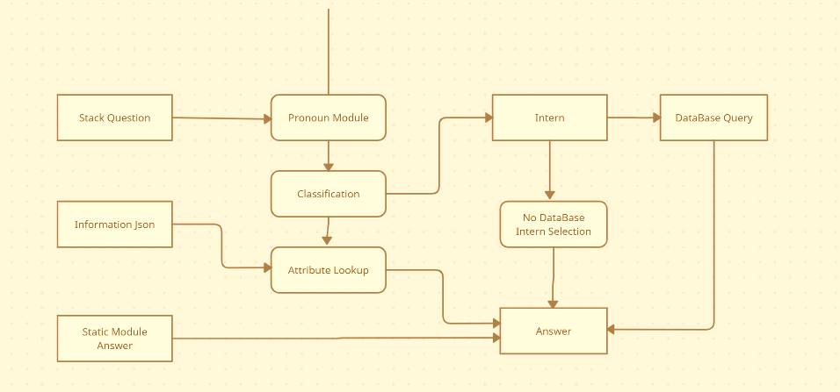

**Annexure B Entity-Relationship (ERD)**

**(Mandatory)**

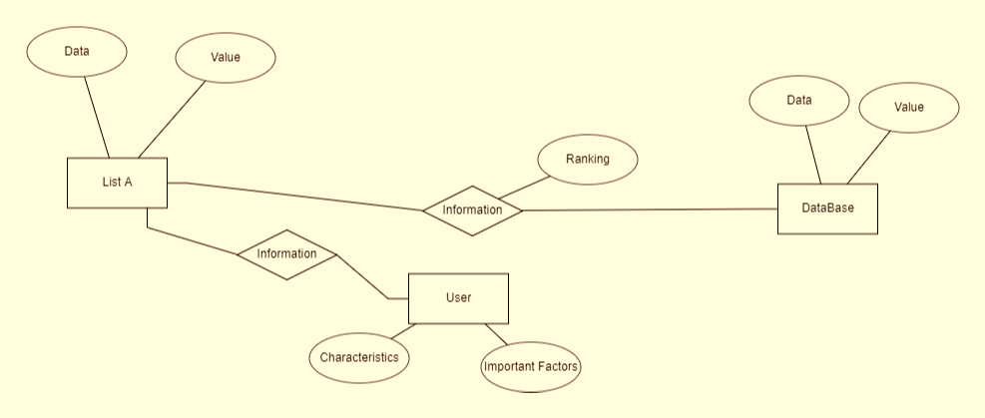

**Annexure C Data Dictionary (DD)**

**(Mandatory)**

**Example: User Table (USR)**

|  |  |  |
| --- | --- | --- |
| **Fields** | **Data type** | **Description** |
| USR-Name | Text | Admin name |
| USR-Password | Text | Admin password |
| USR-Contact-No | Number | Admin Contact |
| USR-Address | Text | City |

**Supplier Table (SUPP)**

|  |  |  |
| --- | --- | --- |
| **Fields** | **Data type** | **Description** |
| SUPP-ID | Number | Supplier ID |
| SUPP-Name | Text | Supplier Name |
| SUPP-Address | Text | Supplier Address |
| SUPP-Contact | Number | Supplier Contact |

**Annexure D Screen Shots-01**

<Guidelines: Show all Pages>

**Home Page:**

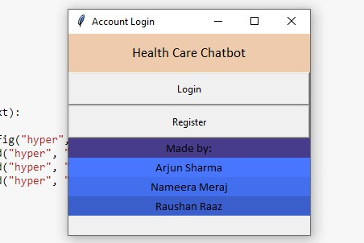

**Login Page:**

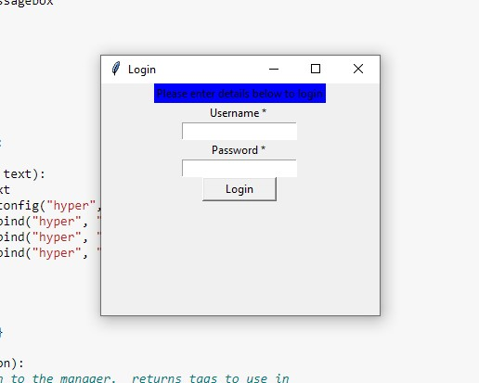

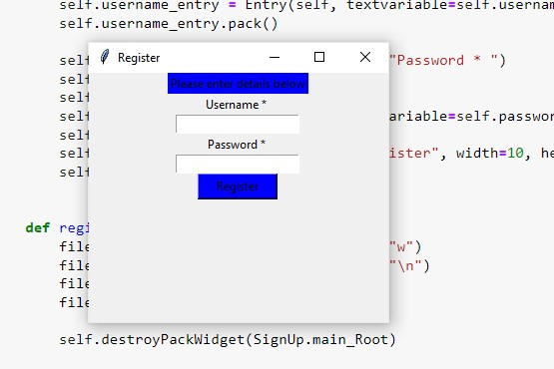**Register Page: 03**

**Process Page: 04**

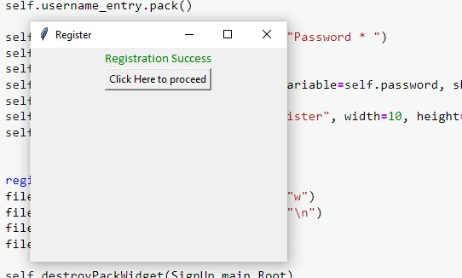

**User Page: 05**

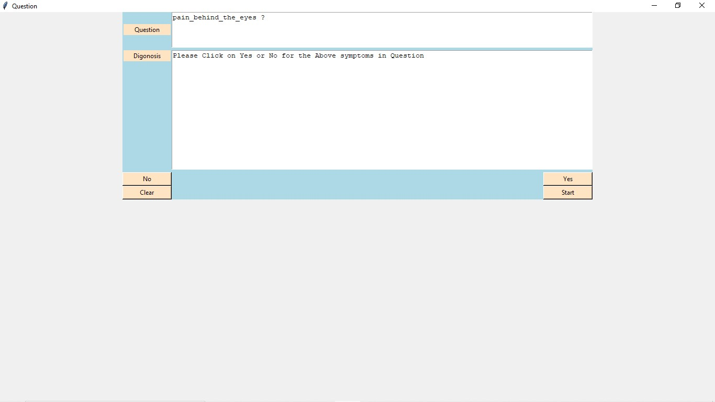

**Result Page: 06**

